

**4 Dimension Printing**

**By**

**Name: Ojubanire Michael**

**Matric No: 20502101**

**Lecturers Name: Dr Akinjobi**

**Course code: CSC 205**

**Table of Content**

CHAPTER ONE:

1. Introduction
   1. Printing Techniques
   2. Fibre Architecture
      1. Hydro-reactive polymers/hydro gels
      2. Cellulose composites
   3. Emergence of 4D Printing from 3D Printing

CHAPTER TWO

1. 4D Relationship with Emerging Tech.
   1. Materials Selection
      1. Thermo Responsive Materials
      2. Moisture responsive materials
      3. Photo/electro/magneto responsive materials
   2. Application of 4D Printing

CHAPTER THREE

1. Emerging and Evolution of 4D Printing

**3.1** Advantages of 4d printing

**3.2** Disadvantages of 4D printing

**3.3** Uses of 4D printing

**3.4** Current Application

**3.5** Possible Application

**INTRODUCTION**

**4-dimensional printing** (**4D printing**; also known as **4D bio-printing**, **active origami**, or **shape-morphing systems**) uses the same techniques of three dimensional printing  through computer-programmed deposition of material in successive layers to create a three dimensional  objects. However, in 4D printing, the resulting 3D shape is able to morph into different forms in response to environmental stimulus, with the 4th dimension being the time-dependent shape change after the printing.[]](https://en.wikipedia.org/wiki/4D_printing#cite_note-:1-1) It is therefore a type of programming matter, wherein after the fabrication process, the printed product reacts with parameters within the environment (humidity, temperature, voltage, etc.) and changes its form accordingly. It uses the help of a 3D programmable software as a point of reference. We have various 3D programmes like Cinema 4D, Blender, Maya, etc.

4D printing refers to single-material or multi-material printing of a device or object that can be transformed from a 1D strand into pre-programmed 3D shape, from a 2D surface into preprogrammed 3D shape and is capable of morphing between different dimensions. Such transformations are facilitated by, e.g., heating, light, or swelling in a liquid, electrochemically and by programming different sensitivity to, e.g., swelling into various parts of the designed geometry. These techniques offer adaptability and dynamic response for structures and systems of all sizes, and promises new possibilities for embedding programmability and simple decision making into non-electronic based materials. Potential applications include; robotics-like behavior without the reliance on complex electro-mechanical-chemical devices as well as adaptive products, garments or mechanisms that respond to user-demands and fluctuating environments. In this paper, we have discussed fundamentals and laws governing 4D printing, materials that are employed in 4D printing along with applications such as soft robotics and challenges that need to be overcome for 4D printing to evolve as a mainstream manufacturing technology.

1.1 **Printing Techniques**

Stereo-lithography  is a 3D-printing technique that uses photo-polymerization to bind substrate that has been laid layer upon layer, creating a polymeric network. As opposed to fused-deposition modeling, where the extruded material hardens immediately to form layers, 4D printing is fundamentally based in stereo-lithography, where in most cases ultraviolet light is used to cure the layered materials after the printing process has completed. Anisotropy is vital in engineering the direction and magnitude of transformations under a given condition, by arranging the micro-materials in a way so that there is an embedded directionality to the finished print.

1.2 **Fiber Architecture**

Most 4D printing systems utilize a network of fibers that vary in size and material properties. 4D-printed components can be designed on the macro scale as well as the micro scale. Micro scale design is achieved through complex molecular/fiber simulations that approximate the aggregated material properties of all the materials used in the sample. The size, shape, modulus, and connection pattern of these material building blocks have a direct relationship to the deformation shape under stimulus activation.

#### 1.2.1 Hydro-reactive polymers/hydro gels

Skylar Tibbits is the director of the Self-Assembly Lab at MIT, and worked with the Stratasys Materials Group to produce a composite polymer composed of highly hydrophilic elements and non-active, highly rigid elements. The unique properties of these two disparate elements allowed up to 150% swelling of certain parts of the printed chain in water, while the rigid elements set structure and angle constraints for the transformed chain. They produced a chain that would spell "MIT" when submerged in water, and another chain that would morph into a wire frame cube when subjected to the same conditions

##### **1.2.2 Cellulose composites**

A scientist explored the possibilities of a cellulose-based material that could be responsive to humidity. They developed a bi-layer film using cellulose steraroyl esters with different substitution degrees on either side. One ester had a substitution degree of 0.3 (highly hydrophilic) and the other had a substitution degree of 3 (highly hydrophobic.) When the sample was cooled from 50 °C to 22 °C, and the relative humidity increased from 5.9% to 35%, the hydrophobic side contracted and the hydrophilic side swelled, causing the sample to roll up tightly. This process is reversible, as reverting the temperature and humidity changes caused the sample to unroll again.

Understanding anisotropic swelling and mapping the alignment of printed fibrils allowed Sydney Gladman *et al*. to mimic the nastic behavior of plants. Branches, stems, bracts, and flowers respond to environmental stimuli such as humidity, light, and touch by varying the internal turgor of their cell walls and tissue composition. Taking precedent from this, the team developed a composite hydrogel architecture with local anisotropic swelling behavior that mimics the structure of a typical cell wall. Cellulose fibrils combine during the printing process into microfibrils with a high aspect ratio (~100) and an elastic modulus on the scale of 100 GPa. These microfibrils are embedded into a soft acrylamide matrix for structure.

### Emergence of 4D Printing from 3D Printing

3D printing, an additive manufacturing technique, is considered as one of the most disruptive innovations in the field of modern manufacturing. It has completely transformed the way parts/components and equipment are manufactured in the industry, along with their design and development. 3D printing enables manufacturers and researchers to develop complex shapes and structures, which were earlier considered impossible with traditional fabrication methods. 3D printing technology has witnessed continuous advancements over the last 3 decades and has evolved drastically. Despite its ability to create complex, bio-inspired, multi-material designs, 3D printing is not yet ready to be adopted in large-scale manufacturing.

The increasing need for flexible objects in various applications, such as self-folding packaging, adaptive wind turbines, etc., has fueled the emergence of 4D printing. Researchers are currently looking ahead of conventional 3D printing, which fabricates structures from a single material, to develop a meta-material structure. The meta-material structure is generated by combining different materials that provide superimposed structural responses when activated by external stimuli. The congruent printing of different materials will form material anisotropy, which enables the object to change the structure by bending, elongating, twisting, and corrugating along its axes. Researchers are further working on expanding these structural changes to create lockers, lifters, microtubes, soft robots, toys, etc. This capability of objects to transform their structure over time by using the behavior of different materials is termed as 4D printing.

The major differences between 3D printing and 4D printing are the use of materials to be printed and the printing facility. Exhibits 1 and 2 depicted below explain the major differences between 3D and 4D printing. 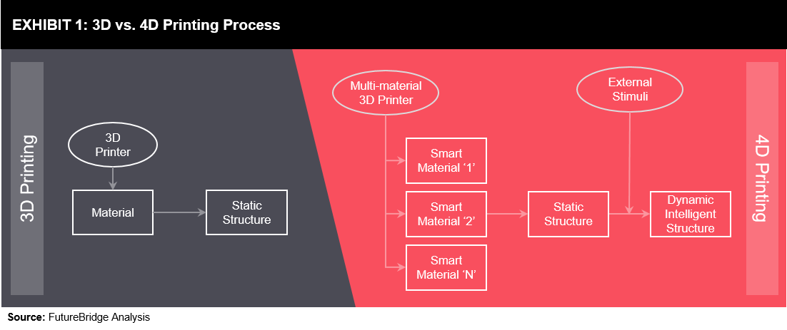

**CHAPTER TWO**

**4D PRINTING RELATIONSHIP WITH EMERGYING TECHNOLOGIES**

As the 4D printing technology is still in its nascent stage, materials used for it are minimal. However, research and advancement in 3D printing are expected to provide new opportunities for 4D printing.

**Smart Material** is one of the highly focused research areas in 4D printing, wherein the deformation mechanism of various materials is synthesized as per their responses to various external stimuli.

**Equipment Design**deals with developing advanced printer technology, which can print multiple materials congruently. Currently, researchers use direct inkjet cure, fused deposition modeling, stereo-lithography, laser-assisted bioprinting, and selective laser melting methods for 4D printing.

Research on **Mathematical Modeling**is essential in understanding the functional structures of 4D printed objects. It predicts the deformation (forward) and formation (backward) process of an object triggered by stimuli.

### Material Selection

Materials for 4D printing are classified based on their environment or the external stimuli they react with. Current classes of smart materials are currently classified into the below categories:.

**Thermo Responsive Materials**

These materials work on the mechanism of the Shape Memory Effect (SME). They are classified into Shape Memory Alloys (SMA), Shape Memory Polymers (SMP), Shape Memory Hybrids (SMH), Shape Memory Ceramics (SMC), and Shape Memory Gels (SMG). Most of the researchers prefer SMPs as it becomes easy to print on these materials. They form and deform when heat or thermal energy is applied as a stimulus

**Moisture Responsive Materials**

Materials that react when in contact with water or moisture are classified under this category. Such materials are widely preferred by researchers, as water is available in abundance, and it can be used in a wide range of applications. The hydrogel is one of the smart materials that fall under this category as it reacts vigorously with water. For instance, hydrogels can increase its size by up to 200% of its original volume, when it comes in contact with water.

**Photo/Electro/Magneto Responsive Materials**

These materials react with light, current, and magnetic fields. For instance, when photo responsive chromophores are infused with polymer gels at specific locations, they swell up absorbing light when exposed to natural light. Similarly, when current is applied to an object containing ethanol, it evaporates, thereby increasing its volume and expanding the overall matrix. Magnetic nanoparticles are embedded into the printed object to gain magnetic control of the object.

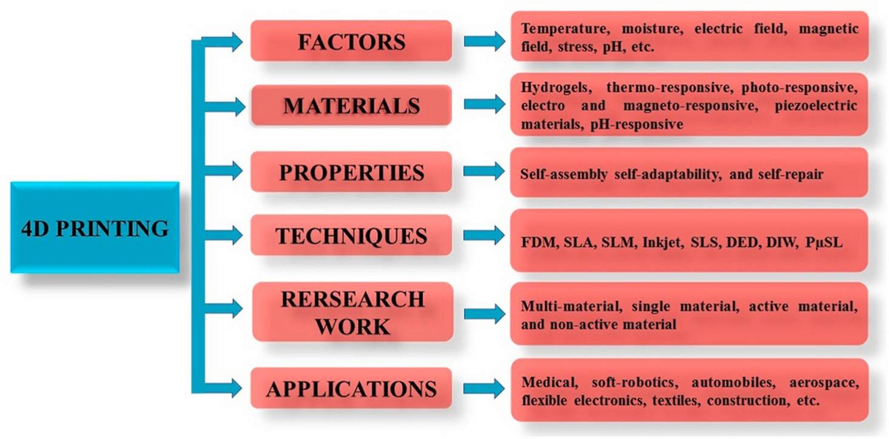

## Applications of 4D Printing

The idea of the pre-programmed intelligent object (created using smart materials) would seem to have several applications in various industries. However, being a novel technology, most of the applications are currently in the research & development phase. Major end-use applications of 4D printing technology are expected to arise from healthcare, automotive, aerospace, and consumer industries. However, the potential of 4D printing is expected to impact other industries as well, such as electronics, construction, industrial, etc, in the near future. The self-inflatable material developed by BMW, in collaboration with MIT has garnered the interest of several experts. The material, made of silicone inflates when triggered by air pulses, could be the future of pneumatics. Apart from the examples given above, there are several other research & development activities undertaken by key players in the 4D printing industry. For instance, some of the applications in the healthcare industry include ‘Targeted Drug Delivery,’ ‘Fabrication of Stents’ for minimal surgical invasion, Development of Shape Changing ‘Splints,’ etc. The development of ‘Soft Robotics’ and ‘Hydraulic and Pneumatic Actuators’ are some of the key applications in this industrial domain. The construction of self-healing roads and bridges could be potential applications in the construction industry.

**Chapter Three**

**Emerging And Evolution Of 4D Printing**

The Picture below showcases the current phase of technological developments in 4D printing. Being in the innovation trigger phase, the technology has certainly created a lot of hype; however, it will take more than 10 years to reach the plateau of productivity.

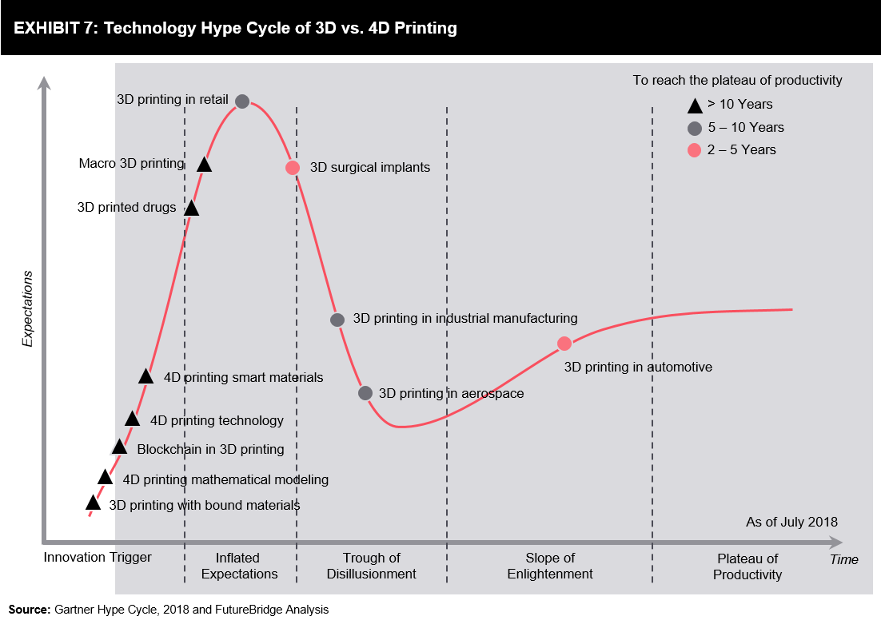

The hype cycle also pinpoints that several advancements in 3D printing are still in the innovation trigger and inflated expectations phases of the lifecycle. This implies that 3D printing has a long way to go, and 4D printing being the successor of 3D printing could be slow in its progress. However, it is not mandatory that advancements in 4D printing should always follow 3D printing. Apart from the capabilities of a 3D printer (its ability to print multiple materials congruently and to print on several axes), other research areas focusing on smart materials and mathematical modeling does not overtly depend on 3D printing.

**Advantages of 4D printing**

**1. It can print any miniature or life size thing or element.**

**2. it can be used to make equipments that rely on lightweight objects. Eg**

**(tiny parts of a drone)**

**3. In various areas of computer science it can be used to replicate some equipments and chip. (in sensors, Smart Agriculture) etc.**

**4. In smart homes, the smart sensors can be packaged in a 4d printed box**

**5. In smart agriculture it can be used to make the necessary equipment that can make this process possible.**

**6. In self driving cars, the area where the sensors will be placed can be printed by 4D printer.**

**7. In Digital health, there are some equipments that are made from a micro-fibre materials, those kinds of materials can be recreated with a 4D printer.**

**Disadvantages of 4D printing**

**1. It is time consuming.**

**2. It requires constant source of power since its an electronic device**

**3. it is very expensive**

**4. If it gets faulty, the parts are scarce to find**

**5. The materials are expensive to buy.**

**6. For some countries, procuring this printer can be difficult.**

**USES OF 4D PRINTING**

1. Used in aerodynamics (There is a rule in aerodynamics, that the lighter the mass of the body which in this case an air transportation means e.g. planes, helicopter, drone etc. the longer and faster the body gets in air. From this theory we know that there are some areas in an airplane that are 4D/3D printed).
2. Used in Medical Places (During the making of a medical instruments like the ventilator there are parts that can be 4D printed, since there are some area in the machine that are plastic like material)
3. They also used to build houses, over the years as 3D printing was existing, people discovered better use for it by using it to print houses, it saves the use of eco unfriendly materials and the machine print the house with 0.001 accuracy.
4. It also reduces the plastic pollution in the world due to the fact that we can use plastic and the mixture of some chemicals as the material for printing thereby achieving recycling.

**Current Application**

### Biomedical

Dr. Lijie Grace Zhang's research team at the George Washington University [[13]](https://en.wikipedia.org/wiki/4D_printing#cite_note-13) created a new type of 4D-printable, photo-curable liquid resin. This resin is made of a renewable soybean-oil epoxidized acrylate compound that is also biocompatible. This resin adds to the small group of 3D-printable resins and is one of the few that are biocompatible. A laser 3D-printed sample of this resin was subjected to temperature fluctuations from -18 °C to 37 °C and exhibited full recovery of its original shape. Printed scaffolds of this material proved to be successful foundations for human bone marrow mesenchymal stem cell (hMSCs) growth. This material's strong qualities of shape memory effect and biocompatibility lead researchers to believe that it will strongly advance the development of biomedical scaffolds. This research article is one of the first that explore the use of plant oil polymers as liquid resins for stereolithography production in biomedical applications.

Research team of Leonid Ionov (University of Bayreuth) has developed novel approach to print shape-morphing biocompatible/biodegradable hydrogels with living cells. The approach allows fabrication of hollow self-folding tubes with unprecedented control over their diameters and architectures at high resolution. The versatility of the approach is demonstrated by employing two different bio polymers (alginate and hyaluronic acid) and mouse bone marrow stromal cells. Harnessing the printing and post-printing parameters allows attaining average internal tube diameters as low as 20 μm, which is not yet achievable by other existing bio printing approaches and is comparable to the diameters of the smallest blood vessels. The proposed 4D bioprinting process does not pose any negative effect on the viability of the printed cells, and the self-folded hydrogel-based tubes support cell survival for at least 7 days without any decrease in cell viability. Consequently, the presented 4D bioprinting strategy allows the fabrication of dynamically reconfigurable architectures with tunable functionality and responsiveness, governed by the selection of suitable materials and cells.

**Possible Application**

### Cell Traction Force

Cell Traction Force (CTF) is a technique wherein living cells fold and move microstructures into their designed shape. This is possible through the contraction that occurs from acting polymerization and actomyosin interactions within the cell. In natural processes, CTF regulates wound healing, angiogenesis, metastasis, and inflammation Takeuchi et al. seeded cells across two microplates, and when the glass structure was removed the cells would bridge the gap across the microplate and thus initiate self-folding. The team was able to create vessel-like geometries and even high throughput dodecahedrons with this method. There is speculation that utilizing this technique of cell origami will lead to designing and printing a cell-laden structure that can mimic their non-synthetic counterparts after the printing process has completed.

### Electrical and Magnetic Smart Materials

The electrical responsive materials that exist today change their size and shape depending on the intensity and/or direction of an external electric field or applied electrical current. Polyaniline and polypyrrole (PPY) are, in particular, good conducting materials and can be doped with tetrafluoroborate to contract and expand under an electric stimulus. A robot made of these materials was made to move using an electric pulse of 3V for 5 seconds, causing one leg to extend, then removing the stimulus for 10 seconds, causing the other leg to move forward. Research on carbon nanotubes, which are biocompatible and highly conductive, indicates that a composite made of carbon nanotube and a shape memory specimen has a higher electrical conductivity and speed of electro-active response than either specimen alone.

Shape memory composite structures incorporating highly conductive metallic surface layers have also been demonstrated to be highly electrical responsive. Due to its high electrical conductivity enabled by an electroless plated metal surface, these composites may be used in electrical devices for temperature sensing (if using a temperature-responsive shape memory polymer matrix), or as electrical safety devices. B.Q.Y. Chan *et al.* fabricated a multiple-temperature sensing device with various switches triggered at different temperatures. The incorporation of the metallic coating was demonstrated to have no adverse impact on the shape memory performance of the switches.

Magnetically responsive ferrogels contract in the presence of a strong magnetic field and thus have applications in drug and cell delivery. The combination of carbon nanotubes and magnetically responsive particles has been bioprinted for use in promoting cell growth and adhesion, while still maintaining a strong conductivity.

### Commerce and transportation

Skylar Tibbits elaborates on future applications of 4D-printed materials as programmable products that can be tailored to specific environments and respond to factors such as the temperature, humidity, pressure, and sound of one's body or environment. Tibbits also mentions the advantage of 4D-printing for shipping applications - it will allow products to be packaged flat to later have their designed shape activated on site by a simple stimulus. There is also the possibility of 4D-printed shipping containers that react to forces in transit to uniformly distribute loads. It is very likely that 4D-printed materials will be able to repair themselves after failure. These materials will be able to self-disassemble, making their constituent parts easy to recycle.

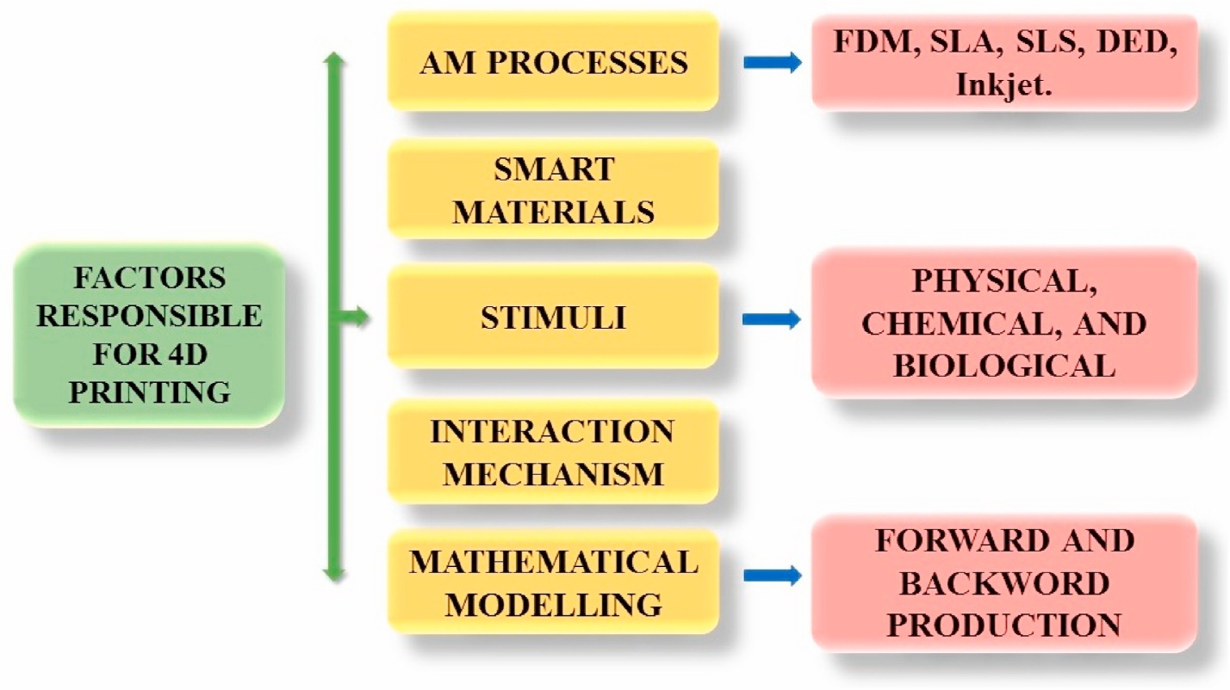

**Factors responsible for 4D printing**

**SUMMARY**

In summary, we can define 4D as the process of printing miniature or life-size replica or model in 4 dimensional space.

We can list the uses of 4D printing

1. Used in aerodynamics (There is a rule in aerodynamics, that the lighter the mass of the body which in this case an air transportation means e.g planes, helicopter, drone etc. the longer and faster the body gets in air. From this theory we know that there are some areas in an airplane that are 4D/3D printed).
2. Used in Medical Places (During the making of a medical instruments like the ventilator there are parts that can be 4D printed, since there are some area in the machine that are plastic like material)
3. They also used to build houses, over the years as 3D printing was existing, people discovered better use for it by using it to print houses, it saves the use of eco unfriendly materials and the machine print the house with 0.001 accuracy.
4. It also reduces the plastic pollution in the world due to the fact that we can use plastic and the mixture of some chemicals as the material for printing thereby achieving recycling.

The process undergoing when its printing is what we know as sterolithography

**ADVANTAGES OF 4D PRINTING**

1. It can be used ti replicate anything.
2. It is used in various aspects of computer science
3. It reduces the plastic pollution in the world.

**DISADVANTAGES OF 4D PRINTING**

1. It is very expensive.
2. It takes time to print
3. It requires constant source of power.

**CONCLUSION**

In conclusion, 4D printing has not fully evolved to the expected level but 4D printing **provides benefits to medical practitioners especially in** the areas not covered by 3D printing technologies. 4D printing helps to create a 3D physical object by adding smart material layer by layer through computer-operated computer-aided design (CAD) data.

The most obvious advantage of 4D printing is that **through computational folding**, objects larger than printers can be printed as only one part. Since the 4D printed objects can change shape, can shrink and unfold, objects that are too large to fit a printer can be compressed for 3D printing into their secondary form.

As per market reports, the 4D printing sector would be worth **about USD 313.1 million by 2025**. The report attributes this exponential rise in the market to the high demand for 4D materials in the military, defense, aerospace and healthcare industries

4D printing is applied in **various sectors such as engineering, medicine, and others**. 4D printed proteins could be a great application. With this new dimension, 3D printed objects can change their shape by themselves over the influence of external stimuli, such as light, heat, electricity, magnetic field, etc.